

Nilkamal School of Mathematics Applied Statistics & Analytics
DEPARTMENT OF STATISTICS
M.Sc. Statistics and Data Science

SENTIMENT ANALYSIS ON STOCK TWEETS

Group number-8 Tanmay Desai- A006 Rohit Fuke – A010 Jayesh Khot- A027 Raj Malkar – A033
Adith Peringathara – A042

Project Mentor
Dr. Pradnya Khandeparkar

ACKNOWLEDGMENT

We, the students of NMIMS NSOMASA, Department of MSc Statistics and Data Science, Semester 2, acknowledge our gratitude to all the individuals associated with this project.
First of all, we would like to pay our respect to our mentor, Dr. Pradnya Khandeparkar, who has guided us and provided us with loads of knowledge, inspiration, and motivation throughout the course of the project. It would not have been possible for us to complete the same without his sincere and affectionate help.
Secondly We would also like to extend our gratitude to our Dean, Dr. Sushil Kulkarni, for giving us an opportunity to work on such projects.
Next, we would like to thank SVKM's Library for allowing us to access the portal through which we got the required research papers, datasets, and study material needed for the project.
Lastly, we thank our faculty, parents, and friends who contributed to some extent to complete the same.

TABLE OF CONTENTS:

Sr.no | Topic | Page No.
1 | Motivation | 4
2 | Introduction | 5
3 | Objectives | 6
4 | Literature review | 7
5 | Glossary | 9
6 | Dataset and Description of the Dataset | 14
7 | Analysis | 16
8 | Conclusion | 18
9 | Limitations | 20
10 | Future Scope | 21
11 | References | 22

- MOTIVATION:
Conducting a project on sentimental analysis of stock tweets is a unique and cutting-edge topic that combines finance, sentiment analysis, and data analysis.
Sentimental analysis of stock tweets has practical applications in the real world, particularly in the finance industry. Your report can highlight the relevance of sentiment analysis in understanding stock market dynamics, investor decision-making, risk management, and trading strategies. It can also showcase how sentiment analysis can be used as a tool in practical applications, such as portfolio management and market monitoring.
In today's digital era, social media platforms, including Twitter, have become important sources of information dissemination and can significantly impact financial markets. Your report on sentimental analysis of stock tweets is timely and relevant, as it can shed light on the role of sentiment in stock price movements in the current market environment.
Completing a project on sentimental analysis of stock tweets can demonstrate our research and analytical skills, as well as our ability to apply theoretical concepts to real-world data. It can enhance our academic and professional profile, showcasing our expertise in finance, data analysis, and sentiment analysis, which can be valuable for our future academic or professional endeavors
As we have interest in finance, data analysis, or sentiment analysis, working on this project can be personally fulfilling and motivating. It allows us to explore a topic that you are passionate about and develop a deep understanding of the subject matter. It can also serve as a stepping stone for further research or career opportunities in related fields.

- INTRODUCTION:
The stock market is influenced by various factors, including investor sentiment, market sentiment, and external events. In recent years, social media platforms, particularly StockTwits, have emerged as a major source of information and sentiment about stocks, with millions of tweets being posted daily. Sentimental analysis of stock tweets involves extracting sentiment or emotions from these tweets to gain insights into investor sentiment and its potential impact on stock prices.
In this project, we focus on sentimental analysis of stock tweets for Apple Inc., one of the leading technology companies. We utilize natural language processing (NLP) to clean raw data, BERT (Bidirectional Encoder Representations from Transformers) to classify the sentiment, also we use VADER(Vader and keywords based classification) and keywords-based classification and LSTM (Long Short-Term Memory) model for time series analysis to analyze the sentiment of stock-related tweets and perform time series analysis on the stock prices of Apple Inc.
The objective of our project is to understand the relationship between sentiment expressed in stock tweets and the stock price movements of Apple Inc. over time. We aim to explore the potential of sentiment analysis techniques in predicting stock price trends and identifying patterns in the stock market.
Our project is unique in that we utilize advanced techniques such as BERT and LSTM, which are state-of-the-art methods in NLP and deep learning, respectively, to perform sentiment analysis and time series analysis on stock data. We also focus on Apple Inc., a well-known and widely followed company in the technology sector, to provide insights and findings that are relevant to investors, financial analysts, and other stakeholders.

- OBJECTIVES:
We propose address the following objectives in the project:
  - To analyze the sentiment expressed in stock-related tweets for NVIDIA. using natural language processing (NLP) techniques, including BERT and VADER models
  - To perform time series analysis on the stock prices of NVIDIA. to identify patterns, trends, sentiment expressed in stock tweets.

- LITERATURE REVIEW

1) StockEmotions: Discover Investor Emotions for Financial Sentiment Analysis and Multivariate Time Series
Author: - Jean Lee, Hoyoul Luis Youn, Josiah Poon, Soyeon Caren Han Public Date: 23 Jan 2023

Link: - Stock Emotions and Financial Analysis and Time series analysis
Description: - The paper "StockEmotions: A Dataset for Detecting Emotions in the Stock Market" introduces a new dataset for detecting emotions in the stock market using natural language processing (NLP) techniques. The authors highlight the growing interest in applying NLP in the financial domain, but also acknowledge the limited availability of resources for such research. The dataset, StockEmotions, consists of 10,000 English comments collected from StockTwits, a financial social media platform. The paper draws inspiration from behavioral finance, which explores the role of public mood and financial sentiment in investment decisions. The authors propose 12 fine- grained emotion classes that span the range of investor emotions, in addition to 2 financial sentiment classes. This fine-grained emotion taxonomy is designed based on existing psychology studies to maximize the impact of the dataset in the financial domain.
The paper conducts a dataset analysis and presents baseline models for downstream tasks. For financial sentiment analysis, seven baseline models, including GRU, DistilBERT, BERT, and RoBERTa, are implemented. DistilBERT outperforms other baselines, achieving high F1-scores for financial sentiment and emotion classification tasks. For time series forecasting, a modified Temporal Attention LSTM model is implemented to identify the importance of text and emotion features for stock market prediction..
The major contributions of the paper are the creation of StockEmotions, a financial- domain-focused dataset for financial sentiment/emotion classification and stock market time series prediction, and the demonstration of the dataset's usability through downstream tasks. The paper highlights the impact of investor emotions in stock market prediction, which can provide valuable insights for decision-making in the financial domain

- GLOSSARY

Natural language Processing (NLP)
It refers to a subfield of artificial intelligence (AI) that focuses on enabling computers to understand, interpret, and process human language in a way that is similar to how humans do. NLP involves the use of algorithms, machine learning techniques, and linguistics to enable machines to understand and generate human language, analyze text, extract meaning from written or spoken words, and perform tasks such as sentiment analysis, text summarization, machine translation, speech recognition, and question answering. NLP has many real-world applications, including chatbots, virtual assistants, language translation, sentiment analysis in social media, voice recognition systems, and information extraction from documents.

  - Text Acquisition
  - Text Preprocessing
  - Tokenization
  - lemmatization
  - Stopword Removal
  - Text Feature Extraction
  - Text Analysis
  - Model Training and Evaluation
  - Model Deployment
  - Model Monitoring and Maintenance

Valence Aware Dictionary for Sentiment Reasoning(VADER)

VADER sentiment analyzer calculates the sentiment of a text document based on a lexicon of words and phrases that have been rated according to their valence, i.e., the degree to which they are positive, negative, or neutral. The lexicon contains about 7500 lexical features including words, emojis, acronyms, and other sentiment-laden tokens.

The valence rating for each lexical feature is based on human raters who assigned a score between -4 (most negative) and +4 (most positive) to each feature. In addition to valence, the lexicon also contains ratings for polarity and intensity of each feature.

What is Valence Score?

It is a score assigned to the word under consideration by means of observation and experiences rather than pure logic.

Consider the words 'terrible' , 'hopeless', 'miserable'. Any self-aware Human would easily gauge the sentiment of these words as Negative.While on the other side, words like 'marvellous', 'worthy', 'adequate' are signifying positive sentiment.

How does VADER calculate the Valence score of an input sentence?

VADER makes use of certain rules to incorporate the impact of each sub-text on the perceived intensity of sentiment in sentence-level text. These rules are called Heuristics. There are 5 of them.

Punctuation, namely the exclamation point (!), increases the magnitude of the intensity without modifying the semantic orientation. For example: “The weather is hot!!!” is more intense than “The weather is hot.”
Capitalization, specifically using ALL-CAPS to emphasize a sentiment-relevant word in the presence of other non-capitalized words, increases the magnitude of the sentiment intensity without affecting the semantic orientation. For example: “The weather is HOT.” conveys more intensity than “The weather is hot.”

Degree modifiers (also called intensifiers, booster words, or degree adverbs) impact sentiment intensity by either increasing or decreasing the intensity. For example: “The weather is extremely hot.” is more intense than “The weather is hot.”, whereas “The weather is slightly hot.” reduces the intensity.

Polarity shift due to Conjunctions, The contrastive conjunction “but” signals a shift in sentiment polarity, with the sentiment of the text following the conjunction being dominant. For example: “The weather is hot, but it is bearable.” has mixed sentiment, with the latter half dictating the overall rating.

Catching Polarity Negation, By examining the contiguous sequence of 3 items preceding a sentiment-laden lexical feature, we catch nearly 90% of cases where negation flips the polarity of the text. For example a negated sentence would be “The weather isn't really that hot.”.
Compound VADER scores for analyzing sentiment

The compound score is computed by summing the valence scores of each word in the lexicon, adjusted according to the rules, and then normalized to be between -1 (most extreme negative) and +1 (most extreme positive). This is the most useful metric if you want a single unidimensional measure of sentiment for a given sentence.

As explained in the paper, researchers used below normalization.
𝑥
√𝑥² + 𝛼

where x = sum of valence scores of constituent words, and α = Normalization constant (default value is 15)

To calculate the sentiment of a text document using VADER, the following steps are performed:

Tokenization: The text is first tokenized into words, punctuations, and emojis.

Scoring: Each token is then scored based on its valence, polarity, and intensity ratings from the lexicon. The valence score ranges from -1 to 1, where -1 indicates most negative sentiment and +1 indicates most positive sentiment. The polarity score indicates whether the sentiment is positive, negative, or neutral, and the intensity score indicates the degree of sentiment intensity.

Summation: The individual scores for each token are then summed up to obtain an overall sentiment score for the text document.

Normalization: The overall sentiment score is then normalized to a scale between -1 and +1, where -1 indicates most negative sentiment, +1 indicates most positive sentiment, and 0 indicates neutral sentiment.

Classification: Finally, the normalized sentiment score is used to classify the text document into one of three categories: positive, negative, or neutral.

The Compound score is a metric that calculates the sum of all the lexicon ratings which have been normalized between -1(most extreme negative) and +1 (most extreme positive) using the formula

alpha is set to be 15 which approximates the maximum expected value of x.
In addition to the compound score of the sentence, Vader also returns the percentage of positive, negative and neutral sentiment features.

Positive sentiment : (compound score >= 0.05)
Neutral sentiment : (compound score > -0.05) and (compound score < 0.05) Negative sentiment : (compound score <= -0.05)

VADER also takes into account certain grammatical and syntactical rules of the text, such as punctuation, capitalization, and degree modifiers (e.g., "very", "extremely") to improve its accuracy. Additionally, VADER has the capability to handle negations and contractions, as well as amplify or dampen the sentiment based on the intensity of certain words or phrases.

BERT (Bidirectional Encoder Representations from Transformers) :

It is a popular deep learning model for natural language processing (NLP) developed by Google. It is a transformer-based model that has been pre-trained on a large amount of text data and is capable of generating contextualized word embeddings, which are representations of words that capture their contextual meaning in a sentence.

BERT has several key features that make it a powerful NLP model:

- Bidirectional Context: BERT is designed to consider both the left and right context of a word in a sentence, allowing it to capture contextual information effectively.
- Transformer Architecture: BERT uses the transformer architecture, which allows it to model long-range dependencies in text and capture contextual relationships between words.
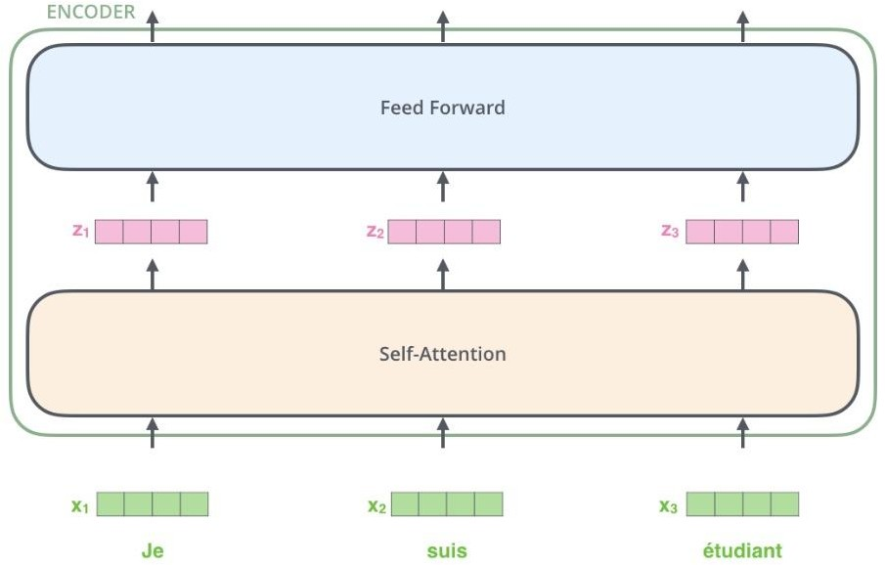
- Pre-training and Fine-tuning: BERT is pre-trained on a large corpus of text data, which enables it to learn general language representations. It can then be fine-tuned on specific NLP tasks, such as text classification, named entity recognition, and question answering, to adapt it to specific tasks with relatively small amounts of task- specific data.
- Deep Architecture: BERT is a deep neural network with multiple layers, enabling it to learn complex patterns in text data and capture high-level semantic representations.
- Large-scale Training: BERT is trained on massive amounts of data, which allows it to capture rich semantic information from diverse sources, leading to better performance on a wide range of NLP tasks.
- State-of-the-Art Performance: BERT has achieved state-of-the-art performance on various NLP benchmark tasks, surpassing previous models and setting new

benchmarks in tasks such as question answering, text classification, and named entity recognition.

BERT has been widely adopted in various NLP applications, including sentiment analysis, text classification, text generation, named entity recognition, question answering, and more, due to its powerful contextualized word embeddings and superior performance on a wide range of NLP tasks

Keyword-based classification

Keyword-based classification is a text classification technique that involves the use of specific words or phrases (known as keywords) to classify a text document into one or more predefined categories or classes.

The basic idea behind this approach is that certain words or phrases are likely to be present in documents of a particular class, and the absence or presence of those keywords can help determine the class to which the document belongs.

Here's a step-by-step overview of how keyword-based classification works:

Define the set of keywords: The first step in keyword-based classification is to define the set of keywords that are most likely to appear in documents of each class. For example, if we want to classify news articles into sports and politics categories, we might choose words like "score", "team", "player" as keywords for sports category and words like "election", "president", "government" as keywords for politics category.

Extract keywords from the input text: The next step is to extract the keywords from the input text. This can be done using various techniques like natural language processing (NLP) libraries, statistical methods, or machine learning algorithms. For instance, we can use a technique like RAKE (Rapid Automatic Keyword Extraction) algorithm to extract important keywords from the text.

Match the keywords with the predefined set of keywords for each category: Once the keywords have been extracted from the input text, we need to match them with the predefined set of keywords for each category. If a significant number of keywords match with the keywords of a particular category, we classify the input text into that category.

Classify the text: After matching the keywords with the predefined set of keywords for each category, we can classify the text into the category that has the highest number of matched keywords.

Evaluation: Finally, we evaluate the performance of the classifier by comparing its predicted class labels with the actual class labels of a set of labeled data. The performance can be measured using metrics such as accuracy, precision, recall, and F1 score.

Keyword-based classification has several advantages such as simplicity, speed, and interpretability. However, it also has some limitations such as limited coverage of topics, inability to handle synonyms or variations in word forms, and the need for a predefined set of keywords for each class. Therefore, it may not be suitable for all types of text classification problems

LSTM MODEL

LSTM (Long Short-Term Memory) is a type of recurrent neural network (RNN) used for time series data analysis and prediction. The steps for building an LSTM model for time series typically include data preparation, feature engineering, defining the model architecture, training the model, evaluating and tuning hyperparameters, testing the model, deploying it in real-world applications, and monitoring and maintaining the model for continued accuracy and reliability. LSTM models are widely used in various domains for analyzing and predicting sequential data.

The mathematical form of an LSTM model

Let's consider a time series data with inputs x(t) at time t, hidden states h(t) at time t, and outputs y(t) at time t.

The LSTM model consists of three main gates: input gate (i), forget gate (f), and output gate (o), which control the flow of information within the LSTM unit. These gates are controlled by activation functions and learnable weights.

The mathematical equations for an LSTM model are:

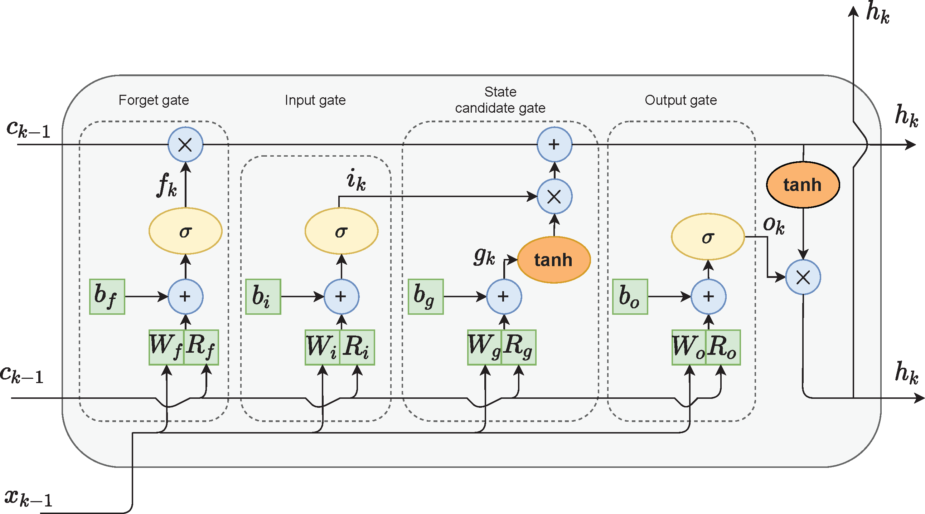

- Input Gate (i): i(t) = σ(Wi * x(t) + Ui * h(t-1) + bi) where Wi, Ui, and bi are the learnable weights for the input gate, σ is the sigmoid activation function, and * denotes matrix multiplication.
- Forget Gate (f): f(t) = σ(Wf * x(t) + Uf * h(t-1) + bf) where Wf, Uf, and bf are the learnable weights for the forget gate.
- Output Gate (o): o(t) = σ(Wo * x(t) + Uo * h(t-1) + bo) where Wo, Uo, and bo are the learnable weights for the output gate.
- Cell State Update (c): c(t) = f(t) * c(t-1) + i(t) * tanh(Wc * x(t) + Uc * h(t-1) + bc) where Wc, Uc, and bc are the learnable weights for updating the cell state, and tanh is the hyperbolic tangent activation function.
- Hidden State (h): h(t) = o(t) * tanh(c(t)) where the hidden state h(t) is computed by applying the output gate o(t) to the updated cell state c(t) through the hyperbolic tangent activation function.
- Output (y): y(t) = softmax(Wy * h(t) + by) where Wy and by are the learnable weights for the output layer, and softmax is the activation function used for multi-class classification problems.

These equations represent the core mathematical operations of an LSTM model, which allow it to capture long-term dependencies and learn patterns from time series data for prediction or classification tasks.

- DATA OVERVIEW :

DATASET: - NVIDIA stock tweets from data.world

LINK: - https://www.kaggle.com/datasets/frankcaoyun/stocktwits-2020-2022-raw
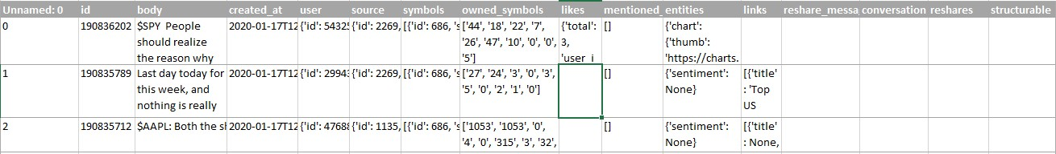

Name | Variable | Type | Description
id | ID | String | Unique identifier for each message
body | Body | String | Contains the text of each message used for nlp , sentimental analysis
created_at | Created_at | Date/Time | Date and time when each message
user | User | String | Username of persons
source | Source | String | Platform or device used to post the message
symbol | Symbols | String | stock ticker symbol mentioned in the message
owned_symbol | Owned_Symbols | String | stock ticker symbol that the user owns or has a position in
like | Likes | Integer | number of likes received
mentioneduser | Mentioned_users | String | Username of other Stocktwits users mentioned in the message
entities | Entities | String | Contains information in the form of hashtags, mentions, or other text
link | Links | String | embedded links
resharemess | Reshare_message | String | Contains information about the message that was reshared or  reposted.
conversation | Conversation | String | Contains information about the conversation, including the ID of the original post and any subsequent replies.

reshare | Reshares | Integer | the number of times the message  has been reshared or reposted by other users.
struct | Structurable | Boolean | this column is a bit more ambiguous, but it could refer to whether or not the message is easily structured or categorized by an algorithm or  program

DATA PREPROCESSING:

  - Handling special characters and emoticons: Tweets often contain special characters, emoticons, and emojis that may not carry much meaning or can cause issues during analysis. You may need to remove or replace them with appropriate representations, such as converting emoticons to text-based representations or removing non- alphanumeric characters.

  - Removing hashtags, mentions, and URLs: Tweets often contain hashtags (#), mentions (@), and URLs, which are specific to Twitter and may not be relevant for NLP analysis. Removing or replacing hashtags, mentions, and URLs can help to reduce noise and irrelevant information in the text data.

  - Handling duplicates: Tweets can be retweeted multiple times, resulting in duplicate data. Removing retweets and duplicates from the dataset can help to ensure that the data is clean and representative of unique tweets.

  - Dealing with mentions and user names: Tweets often mention other users using "@" followed by a username. Depending on the analysis task, you may need to remove or replace user names with generic placeholders to protect privacy or consider them as important entities to retain in the text data

Natural language processing

- Tokenization: Breaking down the text into individual words or tokens to create a foundational unit for further analysis.
- Stopword removal: Removing common and irrelevant words, such as "a," "an," "the," and "is," that do not carry much meaning and can be removed to reduce noise in the text data.
- Lemmatization or stemming: Reducing words to their root or base form to reduce the dimensionality of the text data and group similar words together.
- Feature extraction: Converting text data into numerical or vector representations, such as Bag-of-Words (BoW), Term Frequency-Inverse Document Frequency (TF-IDF), or word embeddings, for further analysis or modeling.

- ANALYSIS
Accuracy Scores on the labeled subset for three model is

Model | Accuracy
Keywords based clasification | 27%
VADER | 63.7%
BERT | 81.85%

So by applying BERT model on stocktwits dataset we get the sentiment for each tweets and we are taking its average day wise as shown below

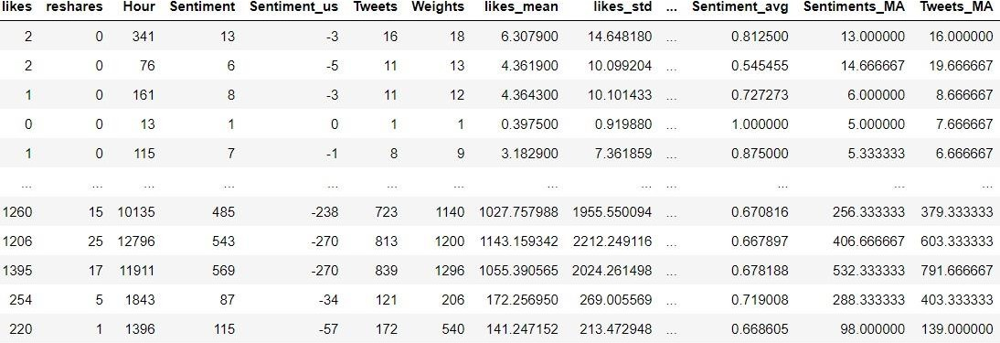

LSTM MODEL:
- Traditional RNNs have difficulty in capturing long-term dependencies
- Handles long term dependencies and memory
- Captures complex relationships between different time series
- Ability to store information over a long period of time
- LSTMs can be trained faster than traditional RNN
•
This is stock price data NVIDIA graphic card company
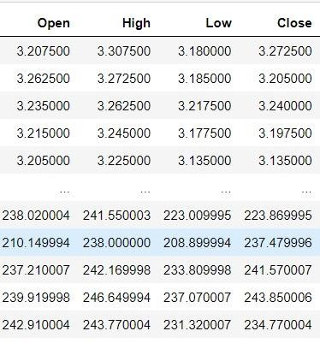

LSTM TIME SERIES WITHOUT SENTIMENT
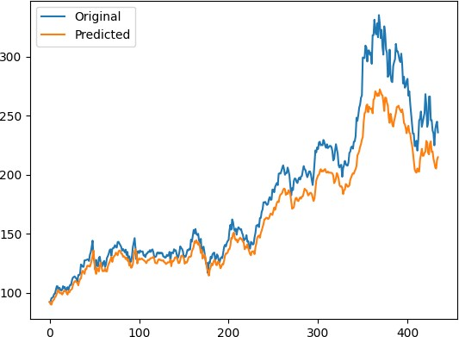

RMSE = 17.13525
LSTM TIME SERIES WITH SENTIMENT
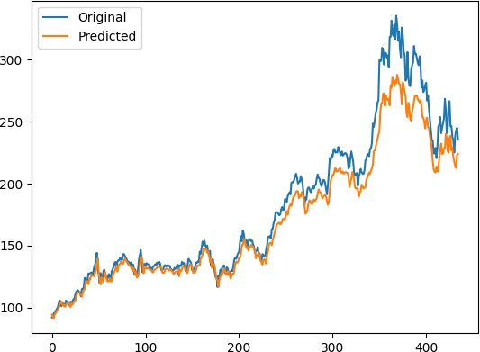

RMSE = 15.18358

So as we compare the RMSE value of two time series we get small RMSE value for time series with sentiment . we can say that its fits marginally better than without sentiment.

- CONCULSION
  - BERT has highest accuracy and performs significantly better than keyword based classification and VADER.
  - LSTM model with sentiment is marginally a better fit compared to without sentimentBERT has highest accuracy and performs significantly better than keyword based classification and VADER.
LSTM model with sentiment is marginally a better fit compared to without sentiment
- LIMITATIONS
  - Limited data: Sentiment analysis algorithms require large amounts of data to train and operate effectively. However, there may be a limited amount of relevant data available, especially for smaller or less well-known companies.
  - Noise: Stock tweets often contain noise such as spam, irrelevant content, and misleading information. This can affect the accuracy of sentiment analysis algorithms and lead to incorrect stock price predictions.
  - Market unpredictability: Stock prices are affected by many unpredictable factors, such as changes in government policies, natural disasters, and unexpected news events.

- FUTURE SCOPE
  - Analyze sentiment for other companies: You could apply the same sentiment analysis techniques used for NVDIA to other companies on Stocktwits
  - Develop a real-time sentiment tracker: create a system that continuously scrapes Stocktwits for sentiment data and updates stock price predictions in real-time.

  - Incorporate additional data sources: explore other data sources, such as news articles or financial reports, to improve the accuracy of your stock price predictions.
  - Attention model can be used.
- REFERENCES Research Paper

Stock Emotions and Financial Analysis and Time series analysis
BERT
https://jalammar.github.io/illustrated-transformer/
https://youtu.be/zJW57aCBCTk?list=PLam9sigHPGwOBuH4_4fr- XvDbe5uneaf6
VADER
https://medium.com/@mystery0116/nlp-how-does-nltk-vader-calculate- sentiment-6c32d0f5046b
https://blog.quantinsti.com/vader-sentiment/ LSTM
https://www.analyticsvidhya.com/blog/2022/03/an-overview-on-long-short- term-memory-lstm/

